

Sri Meenakshi Govt.Arts College for Women (A),

Madurai - 625 002

 Department of Physics

Naan Mudhalvan Scheme

Domain : Sales Force Associate

Project Tile : Build an event management using salesforce

Submitted by

TEAM 1V

TEAM ID: NM2023TMID08289

Team Lead : Ms. Pavithra. T

Team Member 1 : Ms. Pavithra. M

Team Member 2: Ms. Preethi. P

Team Member 3 : Ms. Pragathi. S

Mentors : Dr. K. Vijaya Kumar & Dr. P. Indra Devi

Assistant Professors, Department of Physics, Sri Meenakshi govt.Arts College for Women, Madurai.

April, 22 - 2023

**PROJECT REPORT TEMPLATE**

1. **INTRODUCTION**

**1.1 Overview**

Event management is the process of creating and maintaining an event. This process spans from the very beginning of planning all the way to post-event strategizing.

A he start, an event manager makes planning decisions, such as the time, location, and theme of their event. During an event, event managers oversee the event live and make sure things run smoothly. After an event, event managers are tasked with reviewing event data, submitting KPI and ROI findings, and staying on the ball for any post-event offerings.

All different branches of planning go into event management, including various types of sourcing, designing.

A truly comprehensive event management system allow users and organizers to access and manage all regulation checks, and on-site management. In event management, you could be in the process of creating a conference, a product launch, an internal sales kick-off, or even a wedding. Really, any event that requires considerable planning and execution is event management.

* 1. **Purpose**

Accepts of an event including registrations, marketing and engagement, integrations and physical planning and preparation, reporting and analystics and more.

On college and university campuses, events are happening all the time, whether student-or fauclty- focused and often through in-house or third parties and vendors. When these events take place, it is critical to use an event management system that offers full control and planning capabilities to ensure activities happen on time, in accommodating spaces and keeping in mind the safety of every attaining. A comprehensive event solution will allow campus event planners to book large-scale events, communicate with service providers, and maintain a single source of record for repeatable, measurable events.

**2. Problem definition & Design thinking**

**2.1 Empathy map**

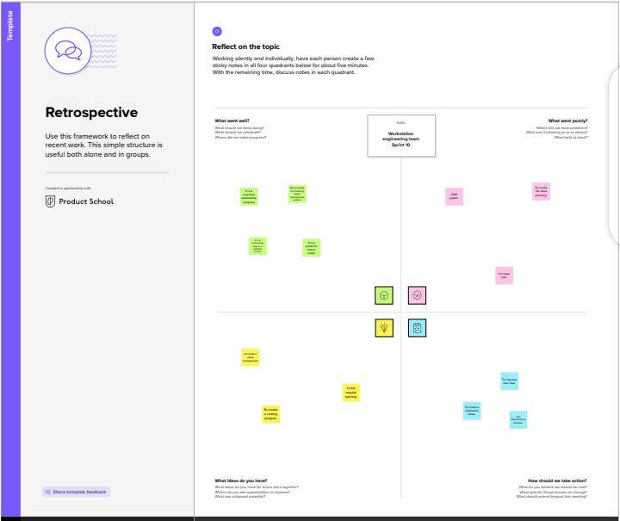

**2.2 Ideation & Brainstorming Map**

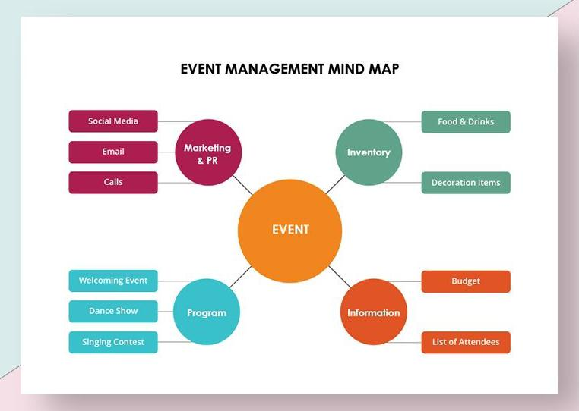

**3.Result**

**3.1 Data model:**

|  |  |  |
| --- | --- | --- |
| **Object name** | **Fields in the object** | |
| **Field Label** | **Data type** |
| Events | City  Start Date | Text  Date/Time |
| Attendees | Id  Phone  Email  Tickets | Auto number  Phone  Email  Picklist |
| Speakers | Bio  Email  Event name | Text area  Email  Look-up relationship |
| Vendors | Email  Phone  Email  Service provider  Event name | Phone  Email  Email  Text  Look–up relationship |

**3.2 Activity and screenshot**

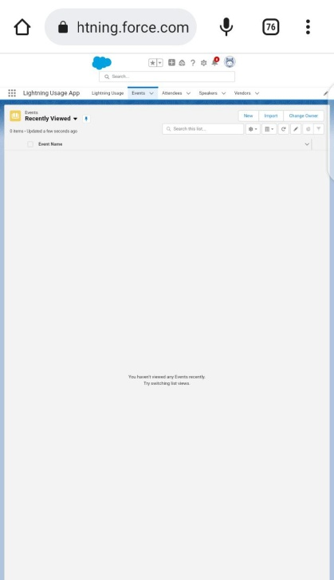

**Description:**

These event types provide more granular visibility in user behavior on Lightning by separating user data into four distinct categories: Lightning Errors, Interactions, Page Views, and Performance.

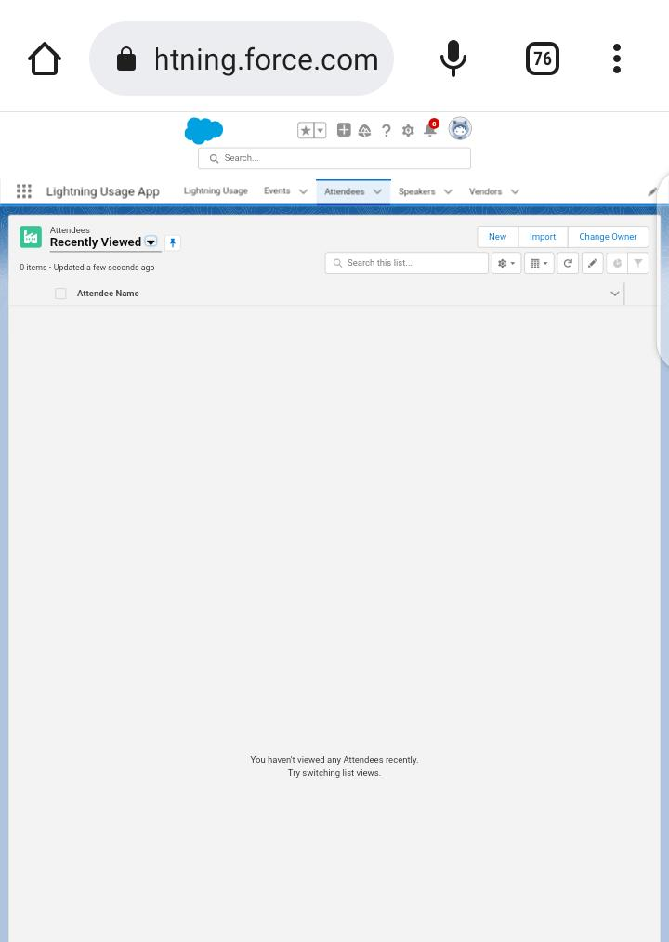

**Description:**

In Lightning Experience and the Salesforce mobile app, the people you invite to your events are called attendees. In Salesforce Classic, they're called invitees. In Lightning Experience and the Salesforce mobile app, users get the Attendees field when admins add it to Event page layouts or quick actions layouts.

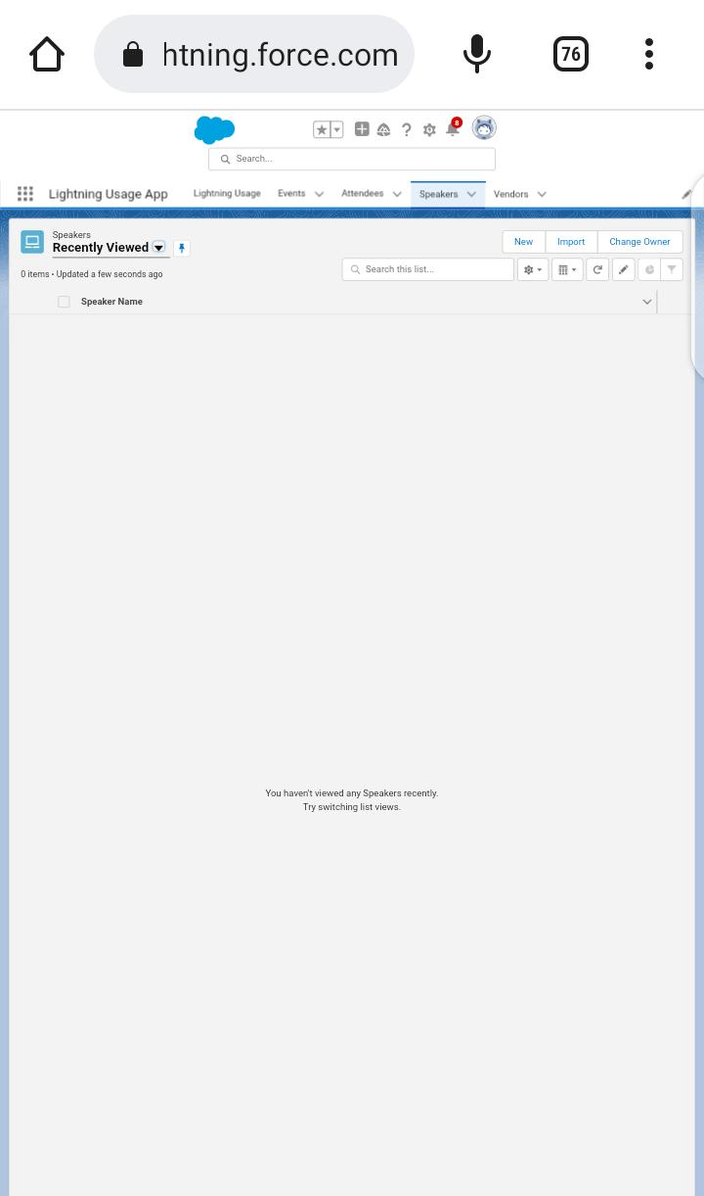

**Description**:

Objects are standard or custom objects that stores record data in the force.com database. Speakers may want to explain an idea or process, share new information, or show how to do something. When a speaker aims to persuade an audience, they want them to adopt a new position or belief, to change their minds, or to be moved to action.

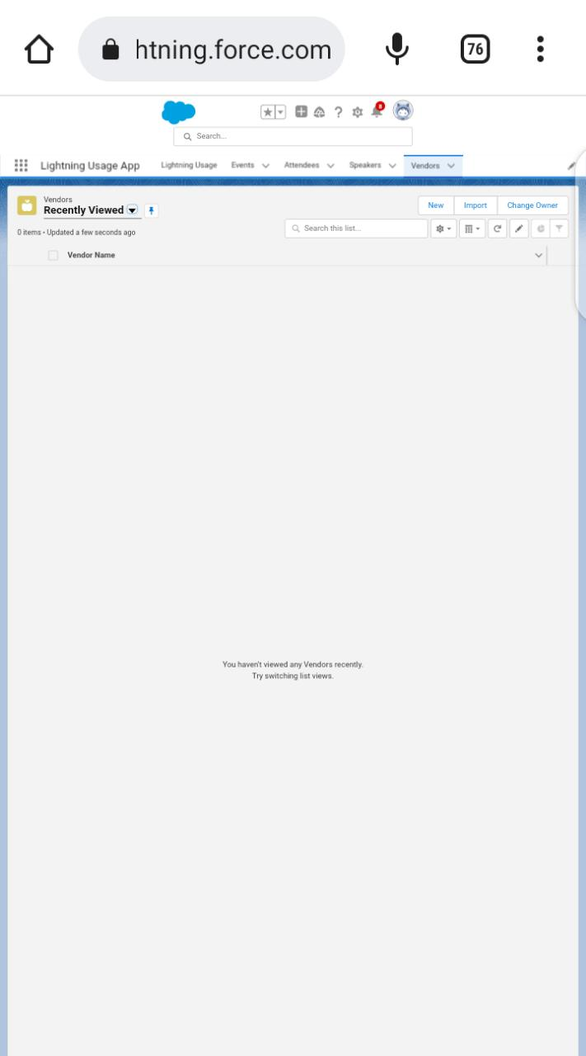

**Description:**

The Salesforce vendor management platform allows you to connect your vendors with product experts and securely provide them with relevant CRM information. Vendors can track sales assets, product information, and even training and certification courses.

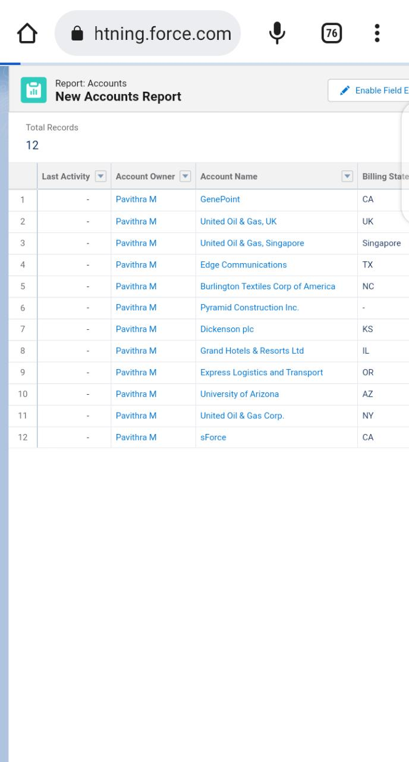

**4. Trailhead Profile Public URL**

Team Lead - <https://trailblazer.me/id/pavi0111>

Team Member 1 - <https://trailblazer.me/id/pavi1310>

Team Member 2 - <https://trailblazer.me/id/preethi030311gmailcom>

Team Member 3 - <https://trailblazer.me/id/pragathi26>

**5. Advantages & Disadvantages**

**Advantages:**

* They They make it less stressful. It goes without saying that organising an event, no matter the type of size, it is going to be stressful.
* ensure it runs smoothly.
* They take care of the legalities.
* They have the right contacts.
* Come and Talk to Us.

**Disadvantages:**

* Expensive.
* You have to pay for add-ons to get the most out of the software.
* Configuration and setup is complex and time-consuming.
* Cluttered interface makes navigation and simple tasks unnecessarily complex.
* The learning curve never seems to end.
* Customer support has a poor reputation.

**6. Applications**

* Time-saving. Event management software saves you time by having all of your tasks centralized in a single platform.
* Event automation.
* Increase engagement rate at events.
* Access to valuable real-time data.
* Personalized reports for continuous improvement.

**7. Conclusion**

An Event Management System provides campus event planners a flexible, fully integrated solution to simplify the event management process and keep your customers, faculty and students happy, while maintaining important reports and data for making real estate and future planning decisions.

**8. Future scope**

The project aim is to provide real-time knowledge for all the students who have basic knowledge of Salesforce and Looking for a real-time project. This project will also help to those professionals who are in cross -technology and wanted to switch to Salesforce with the help of this project they will gain knowledge and can include into their resume as well.